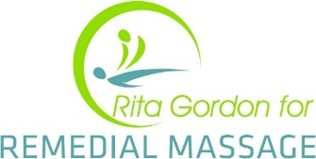

What is Remedial Massage and how does it differ from Relaxation Massage?
In simple words, it means using different techniques and therapies out of my “Remedial Toolbox” and helping with specific postural issues or injuries. This differs as it isn’t a traditional “Full body Massage”. We look at the body in a holistic method and incorporate e.g. stretching, Deep Tissue, Cupping, Quasha, Fascia Release, Dry Needling, Trigger Point Therapy etc. to “straighten” up the body and release specific tension and alleviate injuries and discomfort.

Which is better? Massage, Chiropractic or Physiotherapy?
Today we have a more holistic approach and refer to each other and complement each other’s work. Chiropractic work on the skeletal system in the main but some also do some wonderful body work but obviously for a shorter length of time. Remedial Massage is the body work person and we release the knots and tension and help alleviate discomfort within the muscles. The Physio, they are the Rehabilitation factor and will give you strengthening and stretching homework and also use e.g. TENS machines and techniques like mobilisation etc. Each modality is not better than each other but differ from each other and complement.

