What Face Skin Defects Are Trying to Tell You About Your Health

Sometimes our face reveals more than we might want it to say, and that’s actually an advantage. A close look at your face can help you understand any areas in which there are imbalances in your body, possibly preventing a future disease.

11. Dark circles and bags under the eyes
Dark circles under the eyes are often an inherited feature, and nothing can be done about it. But if you got them recently, you should find out the reason immediately. The most popular ones are a lack of sleep, smoking, hormonal changes, allergies, and overuse of alcohol, coffee, and salty foods.

- You will get long-term effects if you manage to get rid of the underlying cause. But for a temporary measure, a cold compress, special patches, and a good concealer will work.

10. Red nose
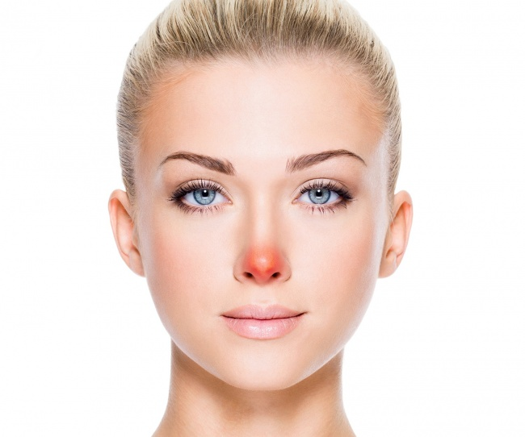
There are many blood vessels on our noses, and their expansion leads to discoloration. This is facilitated by temperature changes, allergies, emotional stress, or a runny nose. But in any case, redness will be temporary if you eliminate the cause.
- However, if your nose is always red, you should pay attention to the condition of your blood vessels, review your lifestyle, and see your doctor for a specific diagnosis.

9. Yellowish face and eyes
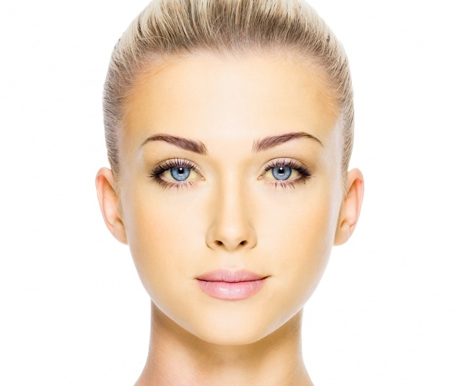
This happens when too much waste accumulates in the body. It is usually observed in babies born before 38 weeks because their liver cannot operate properly. In adults, jaundice can mean more serious problems, including alcohol abuse.
- You should check your liver, gallbladder, and pancreas, and rule out such viral infections as hepatitis and mononucleosis.

8. Unexpected appearance of moles or birthmarks
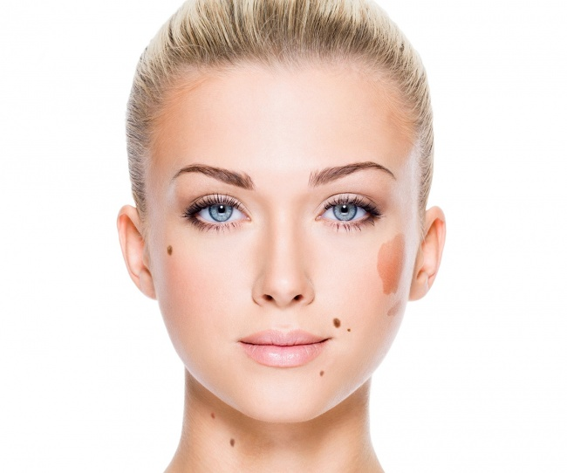
In most cases, there is nothing to worry about, but vigilance is always a good thing. Ask yourself several questions. Are the borders of the mole jagged? Is the color of the mole uneven? Is it bigger in diameter than a pea? Has it changed in the past few weeks?
- Consult your doctor if one of your answers was “yes.” Try to avoid prolonged exposure to the sun, and remember to use SPF creams.

7. Butterfly rash
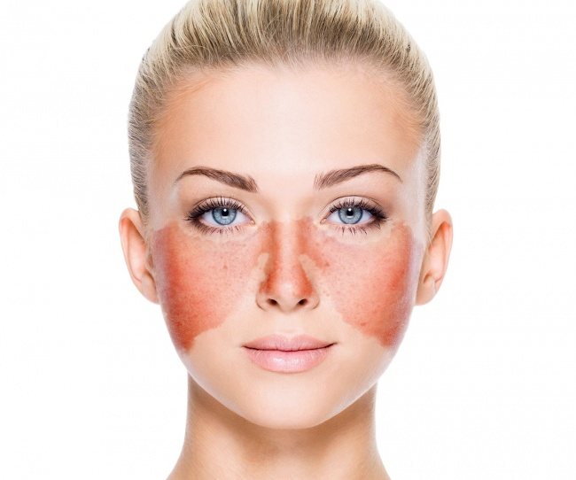
A small rash on the face can be caused by improperly selected cosmetics, allergies, climate change, or excessive consumption of sweets. Once you eliminate the provoking factor, the rash will disappear. But if the rash occupies both cheeks and resembles a butterfly in shape, it can signal lupus.
- Other symptoms of lupus are fever, joint pain, and fingers becoming blue in frosty weather.

6. Peeling skin around the mouth and nose
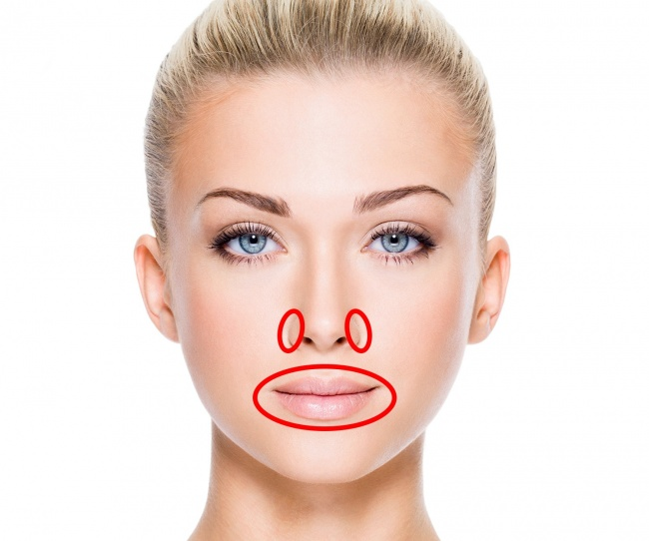
Changes in the skin around the mouth and nose can be a result of various causes, but most often it means a lack of essential vitamins A, C, E, or B in the body. Peeling is often accompanied by general weakness, poor concentration or attention, hair loss, and layered nails.
- It is worth taking the tests and finding out which vitamins are missing. Revise your diet, and add the right foods.

5. Sores around the lips and mouth
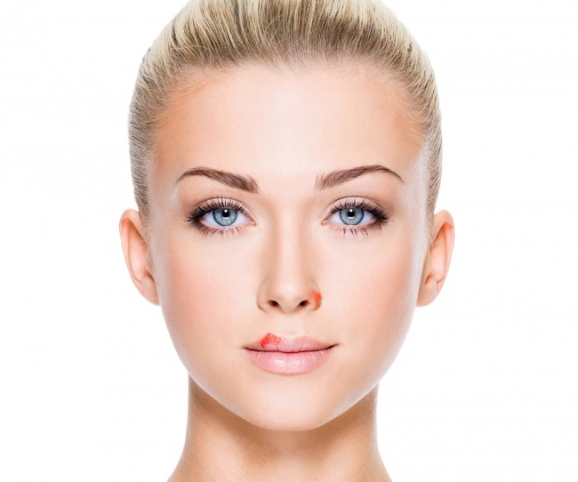
Sores around the lips, mouth, and nose are likely to be caused by the type 1 herpes virus. Once you get the virus, it will stay with you. Sores may break out when the immune system of a person weakens due to stresses, illnesses, or tiredness.
- They usually disappear by themselves. Nevertheless, there are special ointments sold in drugstores.

4. Cracked lips
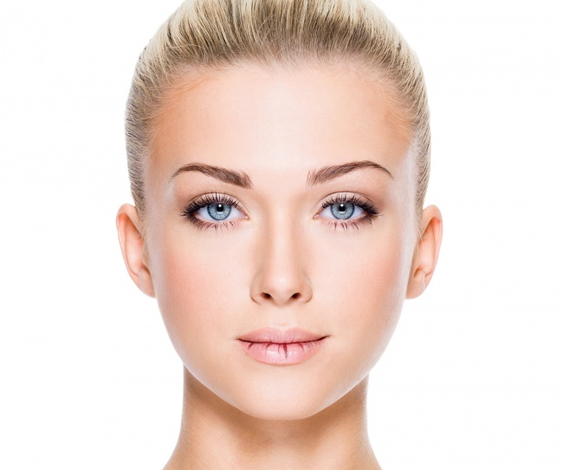
We all get dry and cracked lips from time to time, especially in winter or after a long period in the sun. Cracks can also signify an allergic reaction or a response to a drug.
- The childhood rule of not licking your lips in the cold still works well. Lip balms can also be a great help.

3. Excess of hair on the face
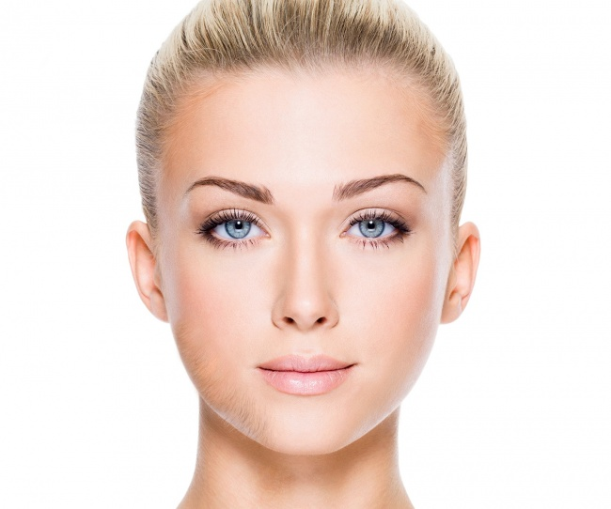
For many people, facial hair may be hereditary. In young women, excess hair may signify that the ovaries aren’t functioning properly. This is called polycystic ovary syndrome and can cause difficulties becoming pregnant.
- It’s recommended that you visit a gynecologist for treatment. Additionally, you can try to avoid consuming products high in sugar.

2. Hyperpigmentation on the face
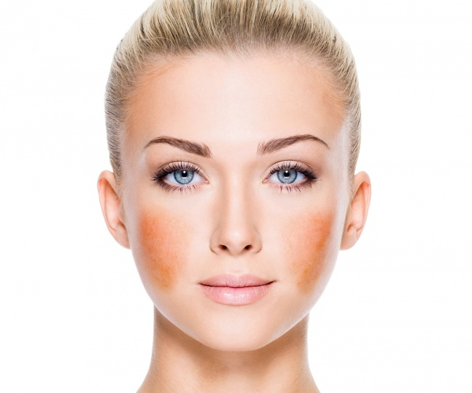
If there are dark symmetrical spots on the cheeks and on the bridge of the nose, this is a classic sign of melasma, a type of hyperpigmentation. It’s more common among women and develops faster among people with darker skin. Frequent sun exposure also stimulates its growth.
- Young women usually get melasma during pregnancy, and it often disappears by itself. However, there are many cosmetic products for fighting hyperpigmentation such as laser therapy, whitening cosmetics, and chemical peelings.

1. Thinning of eyebrows or eyelashes
If eyebrows or eyelashes are thinning but not because of unsuccessful cosmetic experiments, then it can signal problems with the thyroid gland. Its low activity is a sign of hypothyroidism, which is common among people above 50.
- Among other symptoms, one can note sluggishness, dry skin, and unexplainable weight gain. A blood test and a consultation with your doctor are compulsory in this case.

Bonus: The location of acne reflects your internal health.
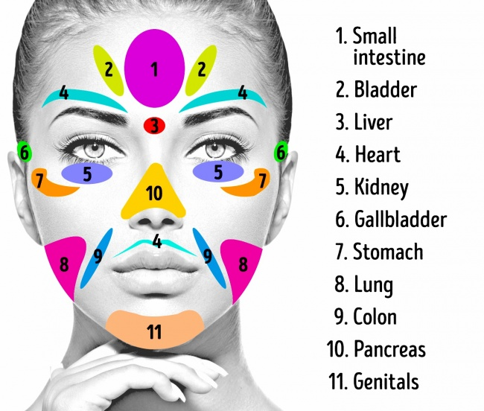
If you keep getting pimples and acne in the same place, it can mean that there is something negative happening in your body. Your skin reflects the inner condition of your body, and the careful analysis of acne can help reveal an upcoming disease and prevent future occurrences of those nasty pimples.
- If acne keeps bothering you for a long time, we recommend that you see a doctor as soon as possible.

