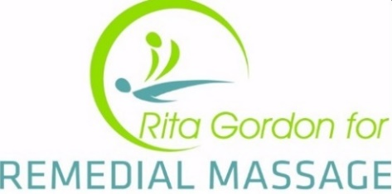

AFTER EFFECTS OF MASSAGE

Are you aware of how important massage aftercare is after your treatment?
That’s the reason why, here at Rita Gordon for Remedial Massage we do individual follow ups on all our client’s wellbeing the day following your treatment.
Why do we do this?
- We truly care!
- Secondly, because this is a period of recovery and detoxing

To fully benefit from your treatment the following guidelines can help you best get your body back into being the best, most healthiest version of yourself.

You may experience some after effects immediately or even up to a day or two later.
A few tips that can help this process are…
- Most importantly, DRINK LOTS OF WATER!!! This helps to flush away toxins and rehydrate your body.
- Relax and rest as much as you can after your treatment, this will help prolong the feelings of wellbeing after your treatment and aid in any healing that needs to occur. Take a bath or a nap if possible.
- Keep muscles warm if you’re feeling cold, again a warm bath or a heat bag can help too.
- Pay attention to general posture and try to remember to follow any specific after care instructions that you therapist has given you.
TRY AVOIDING for a 24 hour period…
- Stimulants including caffeine, alcohol and excess sugar
- Strenuous activity
- Heavy meals
After a treatment your body might experience some reactions that generally subside within 24-48 hours, which include but are not limited to…
- Stiffness, aching muscles, tiredness
- Dizziness or nausea
- Heightened emotions, perhaps even being tearful
- Frequent visits to the toilet, runny nose, coughing… this helps to eliminate waste/toxins
- Headache/disrupted sleep patterns
- Spots on skin & burn more easily due to oil residue on skin
- Slower reflexes (be careful whilst driving)

Remember that should you have any after care concerns, please do not hesitate to contact us as we are more than happy to help.

Rita Gordon for Remedial Massage

