Strengthening the Gluteus Maximus

Glute Bridge

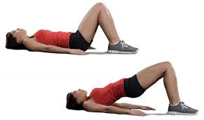
- Find a comfortable place to lie on the ground.
- Lie down on your back with your arms by your side.
- Raise your knees, keeping your back and feet on the ground, as per the first image to the right.
- Slowly raise your bottom (clenched upwards) off the ground, keeping your back straight, and your feet and shoulders on the ground.
- Hold the position shown in the second picture to the right, for 10 seconds.
- Slowly lower yourself down to the first position in the first picture to the right.
- Repeat steps 2 to 6, with three sets of ten repetitions.

Squats with an Elastic Band (See next page for diagram)

- Stand with your legs slightly apart, and your back slightly arched.
- Bend your legs until your thighs are horizontal (parallel to the ground).
- Using two elastic bands (one under each foot), extend your arms and grab the bands with an overhand grip.
- Contract your stomach muscles and lower back, inhale and hold your breath. Extend your legs until standing, then exhale.
- Return to your initial position in step 2.
- Repeat steps 2 to 5, with three sets of ten repetitions.
