Strengthen your Gluteus Medius

The Gluteus Medius is a muscle on the side of your hip, and sits underneath your Gluteus Maximus muscle. This muscle works with the Gluteus Minimus to help support your hip, and to internally rotate the thigh. This reduces the stress on your hip, knee and foot by stopping the knee from migrating inwards.
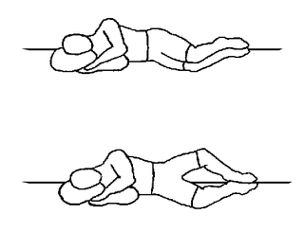

Lie down on a comfortable surface with a pillow underneath your head and your knees bent as shown in the pictogram. Keeping your top knee bent and your feet together, lift your top leg to approximately shoulder height, and slowly lower back down.

Repeat this exercise 10 times on the opposite side/leg, rest, and then repeat each side 10 times for an additional 2 sets.

