Strengthening the Posterior Rotator Cuff
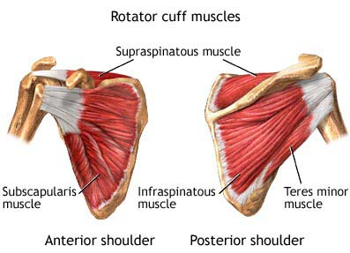
The muscles that make up the Posterior Rotator Cuff can be seen in the image to the left. These are the Supraspinatous muscle, the Infraspinatous muscle, and the Terres minor muscle. In order to strengthen these muscles, there are several exercises that you can to keep the Cuff both flexible and strong.

Before you complete any exercises it is recommended that you first warm up your body by performing 10 minutes of light exercise, such as walking, followed by stretching the muscles that you wish to strengthen.

It is also important that you avoid everyday motions that will aggravate the Rotator Cuff. These include reaching into the back seat of the car and stretches that pull your arms towards your back.

Stretches

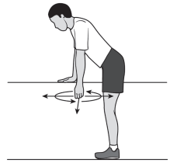

Stretch 1
Lean forward and place one hand on a table/counter. With your free arm, swing it slowly forward and back, side-to-side, and then in a circular motion. Keep your back straight and your knees slightly bent. Repeat with your other arm, with 2 sets of 10.

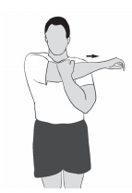
Stretch 2
Gently pull one arm across your chest as far as possible, and hold at your upper arm for 30 seconds. Repeat with your other arm, alternating so that you complete 4 on each side.

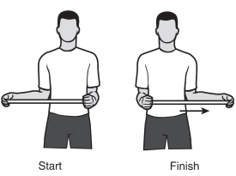
Stretch 3
Using a light stick, hold one end and cup other. Push the stick horizontally whilst keeping the elbow of the shoulder that you want to stretch against the side of your body. Hold for 30 seconds. Repeat with your other arm, alternating so that you complete 4 on each side.
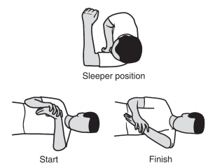
Stretch 4
Lie on your side on the shoulder you wish to stretch. Use your other arm to push your raised arm toward the ground as shown. Stop when you feel the back of your ground shoulder stretch and hold for 30 seconds. Repeat with your other shoulder, alternating so that you complete 4 on each side.

Strength

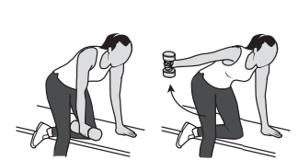
Exercise 1
Take up the position shown on a chair/bench with a weight in your right hand. Raise your arm slowly, rotating to the “thumbs up” position, stopping when your arm is parallel to the floor at shoulder height. Count to 5 as you slowly lower your arm. Repeat 3 sets of 20, each arm.
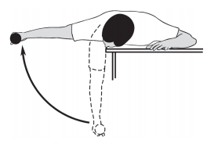
Exercise 2
Take up the position shown on a table/bed. With your weighted arm and keeping it straight, slowly raise it to eye level. Slowly lower it back down. Repeat with 3 sets of 8 for each arm.

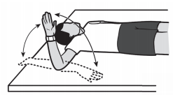
Exercise 3
Take up the position shown on a flat surface, with your hand pointing straight up. Rotate 90 degrees from the elbow slowly, away from the rest of your body (this is for your posterior muscles). Only rotate to 45 degrees if you experience pain at 90 degrees. Repeat each arm, with 3 sets of 20.

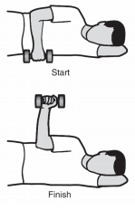

Exercise 4
Take up the position shown on a flat surface. Keeping your elbow at 90 degrees and against your side, rotate your arm until it is vertical, and lower it again to the count of 5.
Repeat each arm, with 2 sets of 10.

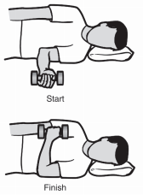
Exercise 5
Take up the position as shown on a flat surface. Put a pillow under your head as this will keep your spine straight. Keeping your elbow against your body, rotate your arm vertically as shown. Slowly lower it back to the count of 5. Repeat each arm, with 2 sets of 10.

